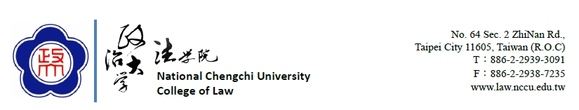

Application for Prospective Visiting Scholar/Researcher
訪問學人申請表

I. Type of Appointment申請類型
□ Visiting Scholar/Researcher (holds a permanent position at another university/institution)
□ Visiting Post-Doctoral Researcher (holds a position at another university/institution)
□ Visiting Ph.D. Student Researcher (enrolled at another university)
II. Applicant Information 申請者資料
○ Prof. ○ Dr. ○ Mr. ○ Mrs. ○ Ms.
Full Name as in Passport 護照中文全名
Date of Birth (YYYY/MM/DD) 出生年月日(年/月/日) |  | Nationality國籍
Gender 性別 | □Male男 □Female女
Home/Postal Address 居住地址
Contact Phone Number 聯絡電話 |  | E-Mail電子郵件信箱
Home University/Institution 校名/服務機關 |  | Titles/Positions職稱
CV attached 簡附履歷 | □Yes有 □No無
Area(s) of Specializaton 學術領域
Research Topic While at NCCU訪問期間研究主題
III. Appointment Information訪問資訊
Arrival Date(YYYY/MM/DD) 入境日期(年/月/日) |  | Departure Date(YYYY/MM/DD) 離境日期(年/月/日)
Length of Stay停留期間 | Days日
Academic Unit接待單位 | National Chengchi University, College of Law國立政治大學法學院
Faculty Member Host接待教師
Name姓名 |  | Titles/Positions職稱
IV. Expected Output預期研究成果
□ Journal Publication期刊出版
□ Conference presentations會議發表
□ Other其他 _____________________
V. Please let us know how you learned of the Visiting Scholar/Researcher Program opportunity.請問您是如何了解訪問學者/研究員計劃
□ National Chengchi University  國立政治大學 |  | □ Website  網站
□ Colleague  同事 |  | □ Other _______________  其他
VI. Checklist 應繳交資料
Please indicate whether you have submitted the following materials:請註明是否繳交以下資料
□Application form申請表
□Proof of eligibility(including Degree Certificate and Employment Certificate) 資格證明(學位證書、在職證明書)
□Research proposal研究計畫
□ I certify that the information submitted is my own work and that all of the statements are true, complete and honestly presented.本人僅此聲明在本申請表填報的資料均屬正確及完整。

Please e-mail this application form and the supporting documents to: yvonne.c@nccu.edu.tw
請將此申請表及相關申請資料發送至yvonne.c@nccu.edu.tw

Signature:
簽名

Date(YYYY/MM/DD):
日期(年/月/日)

